Skillet Name – Activate PANOS Licenses Offline

# 

# 

# Brief Description

This skillet provides the step-by-step licenses activation for PANOS when the Firewall could not connect to Internet.

# How to use

* Login into Panhandler, and import Skillets

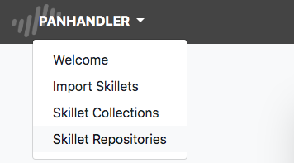

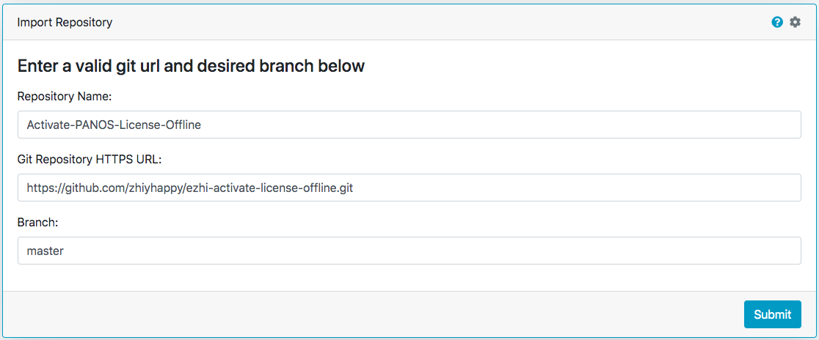

* Get into Skillet Collections and then select skillet: ezhi-activate-license-offline, click Go, then you will get the 6 steps shown on the page.

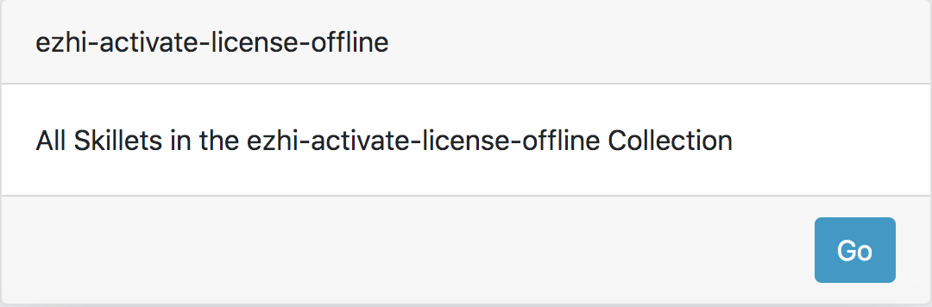

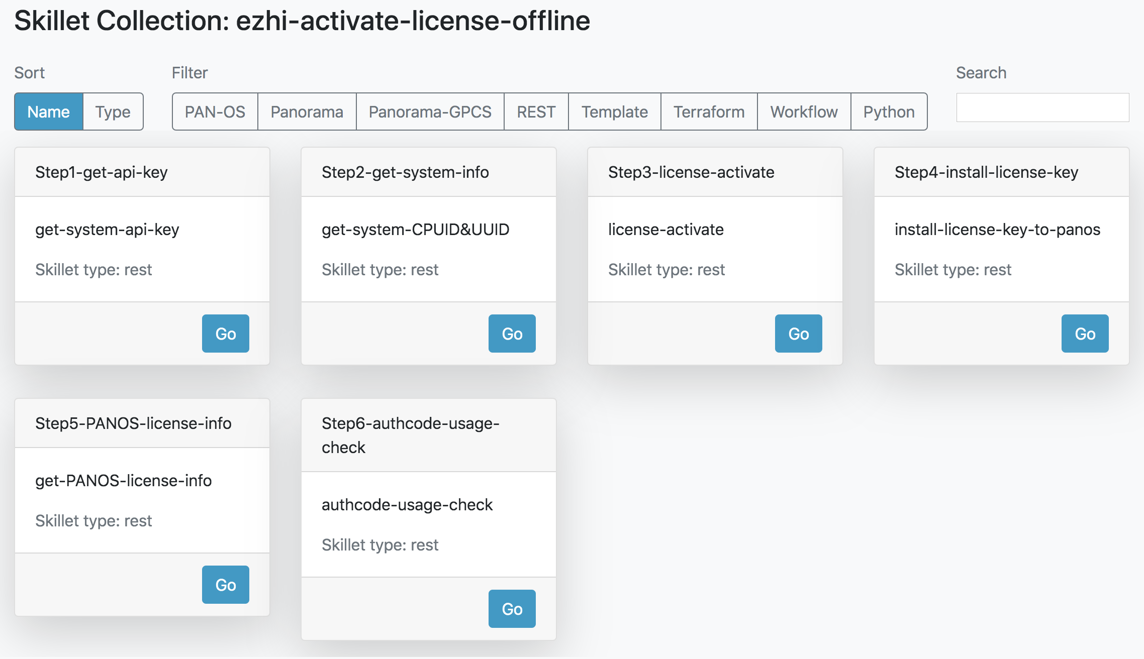

* Click Step 1 – input the Firewall IP address, username and password, then submit, and get the output with API key.

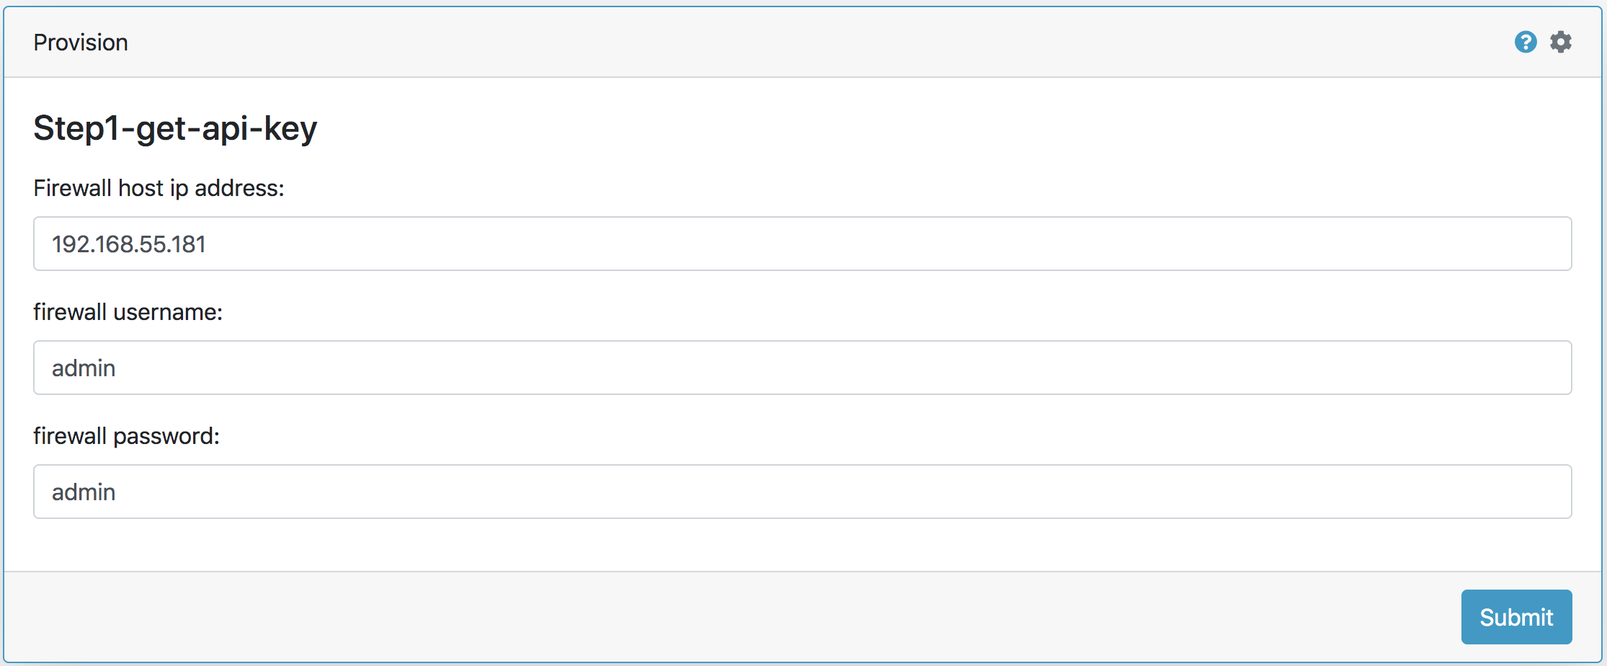

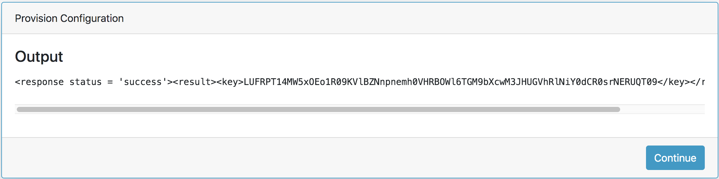

* Click Step 2 – Generate the system information, no need to input the host IP address and API key, which will be transferred from the previous skillet automatically, then you will get the CPUID & UUID

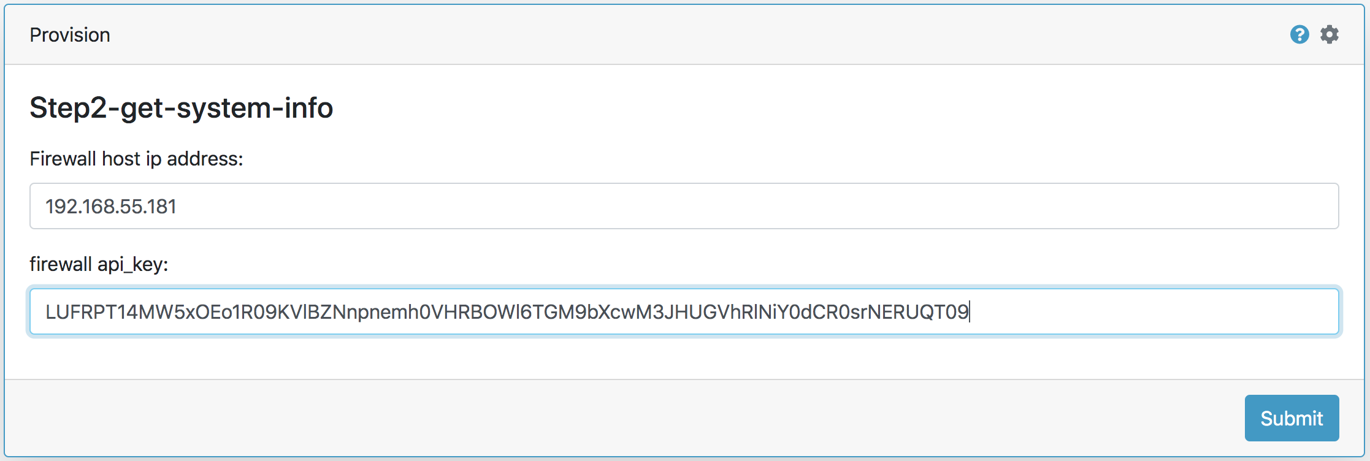

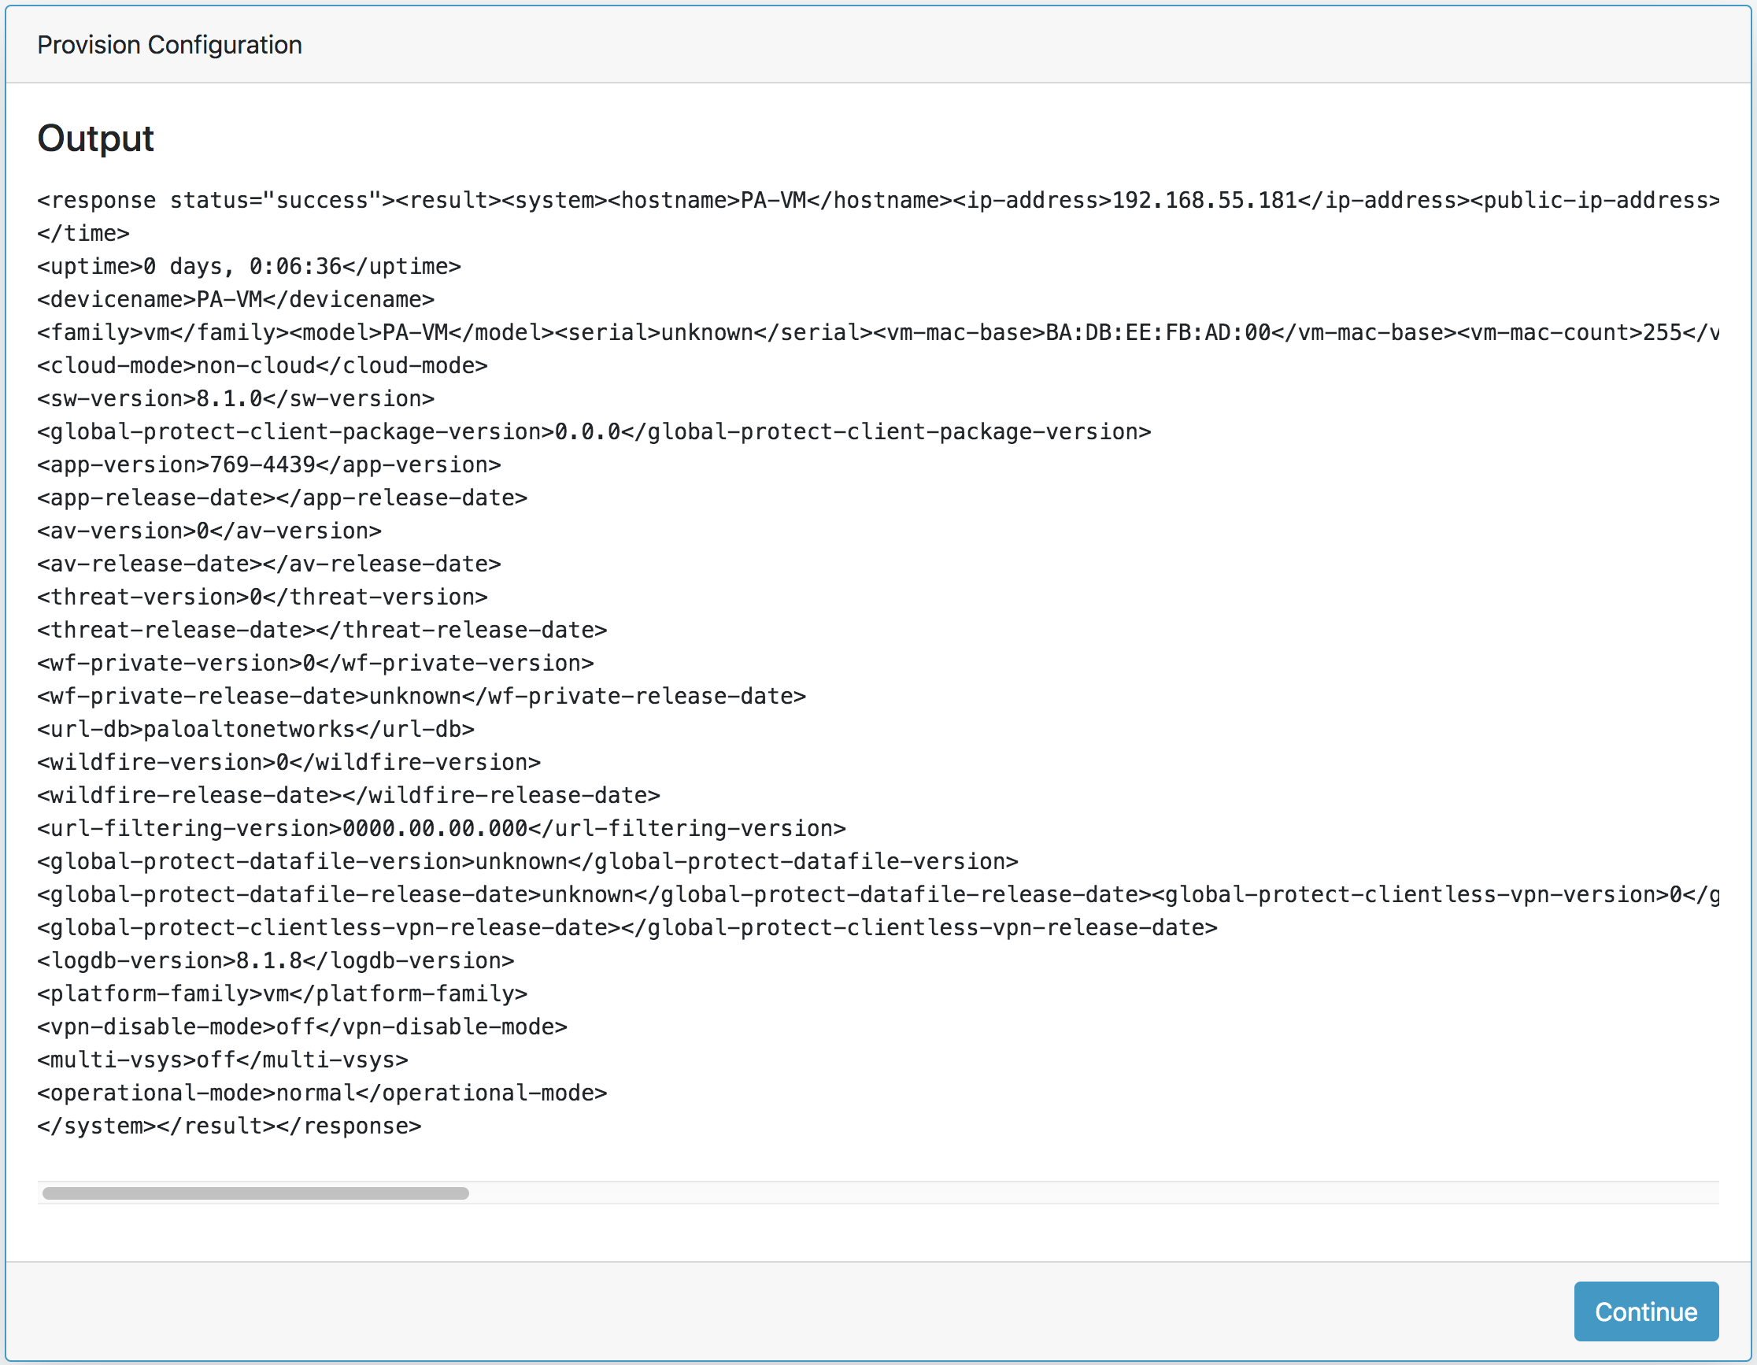

* Click Step 3 – With the licensing API key, CPUID & UUID, as well as the Auth Code, you will activate the device in the licensing server. Here you only need to input the licensing API key and Auth-code, while CPUID & UUID will be transferred from the previous skillet automatically. After submitting you will get the licensing key from licensing server.

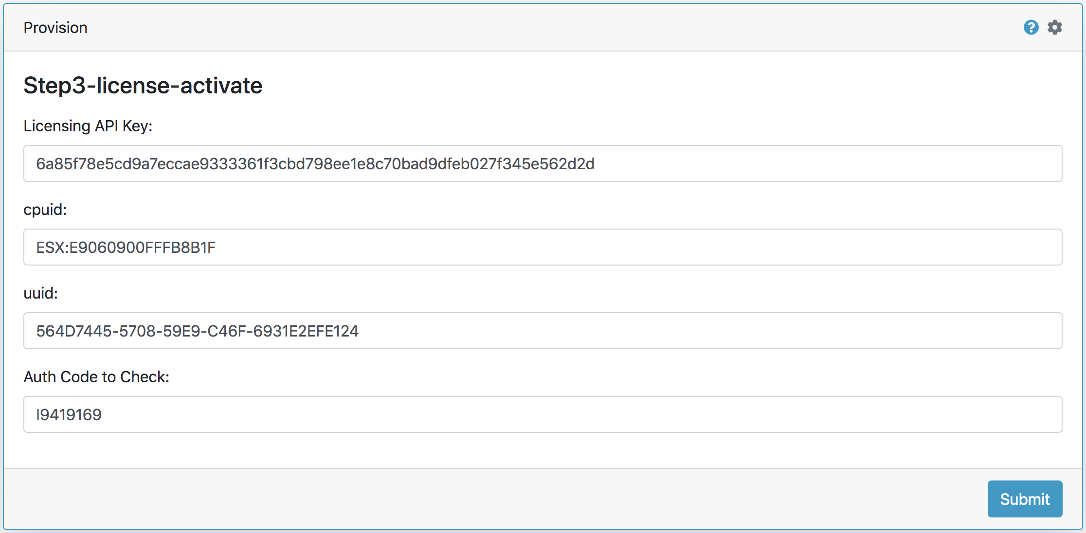

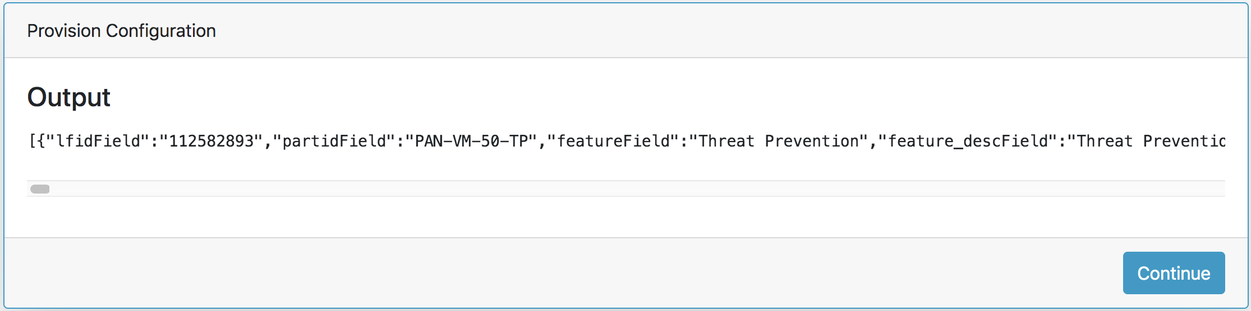

* Click Step 4 – In this step, you need to input the firewall IP address, API key and the license key for a specific feature to install the license into the firewall. You may find each license key after keyField in the output.

Please be noted that the license key generated from step 3 need to be modified to be input into step 4. Here is an example.

This is the license key for Threat Prevention:

MkM7IAEsQ/23UGBmWlnnz9KSD74jalnDJwPxqoptTUF382mxfsR80xQJPqDyKMl6\nmHtETh9sU/Yjn371jrXOGwgurAJXZK+9VIgvtPj4sOiGopqQzJmCqisL8t+tDND+\n+geBhK+lRBOFViKOcAsqd63kv/TIvO5FQ2i0UAh0StcDo1H7xrFbKN2oZ5JQx+nb\nVWGBbzVVNoSaHZwzKDA1wpCMKTp5vZD/6OC4N9QB3XLMAv7PWtgGTI/6v9SyyosX\nXvHtf+LSxplkT3XpY//IzvXgPocbBym5D6w+WheResHHsQUyusXEeWJ5EdoGR947\nsOi7wiUl5ETQKk9vxmQgNA==\n

Because “+” and “\n” will not be recognized in an API call URL, you need to replace the “+” in the string by “%2B”, and also to replace the “\n” by “%0d”. After the replacement, you will get the new license key listed below:

MkM7IAEsQ/23UGBmWlnnz9KSD74jalnDJwPxqoptTUF382mxfsR80xQJPqDyKMl6%0dmHtETh9sU/Yjn371jrXOGwgurAJXZK%2B9VIgvtPj4sOiGopqQzJmCqisL8t%2BtDND%2B%0d%2BgeBhK%2BlRBOFViKOcAsqd63kv/TIvO5FQ2i0UAh0StcDo1H7xrFbKN2oZ5JQx%2Bnb%0dVWGBbzVVNoSaHZwzKDA1wpCMKTp5vZD/6OC4N9QB3XLMAv7PWtgGTI/6v9SyyosX%0dXvHtf%2BLSxplkT3XpY//IzvXgPocbBym5D6w%2BWheResHHsQUyusXEeWJ5EdoGR947%0dsOi7wiUl5ETQKk9vxmQgNA==%0d

Then you could input the modified license key into firewall license_key blank and submit to install the license successfully into the firewall.

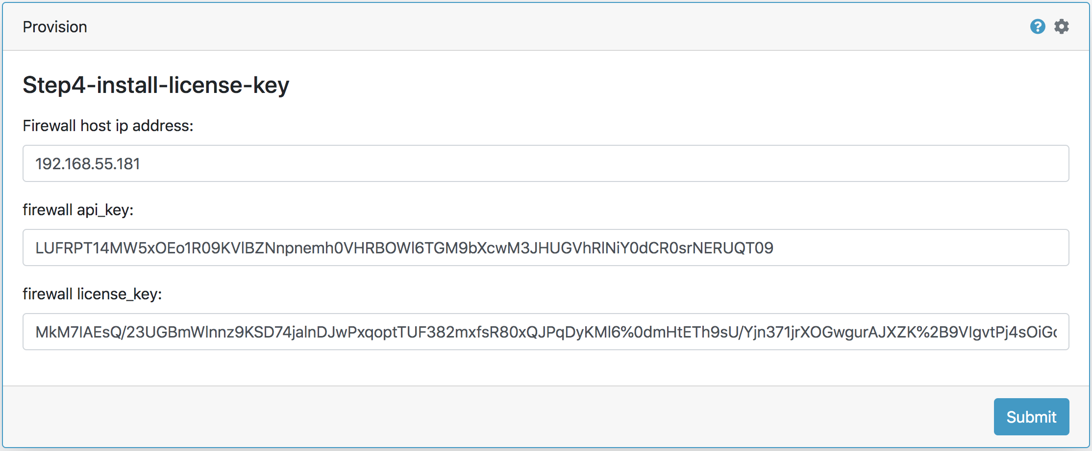

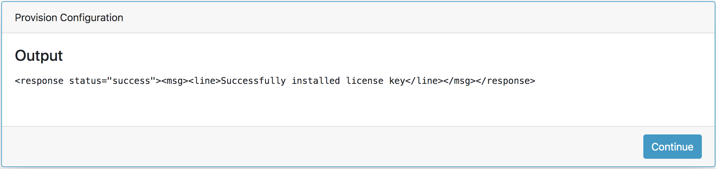

Please repeat step 4 until all license keys have been installed into the firewall.

[Notice]

*We suggest you install the feature and support licenses firstly, while install the VM firewall standard license at last, because standard VM firewall license will cause firewall to reboot and make all the licenses to be active.*

*Before you start the next step, please wait for a few minutes for the firewall to finish reboot.*

* Click Step 5 – In this step, you will get the firewall license information via API call, the output information will include all the feature licenses and support license, with expire date.

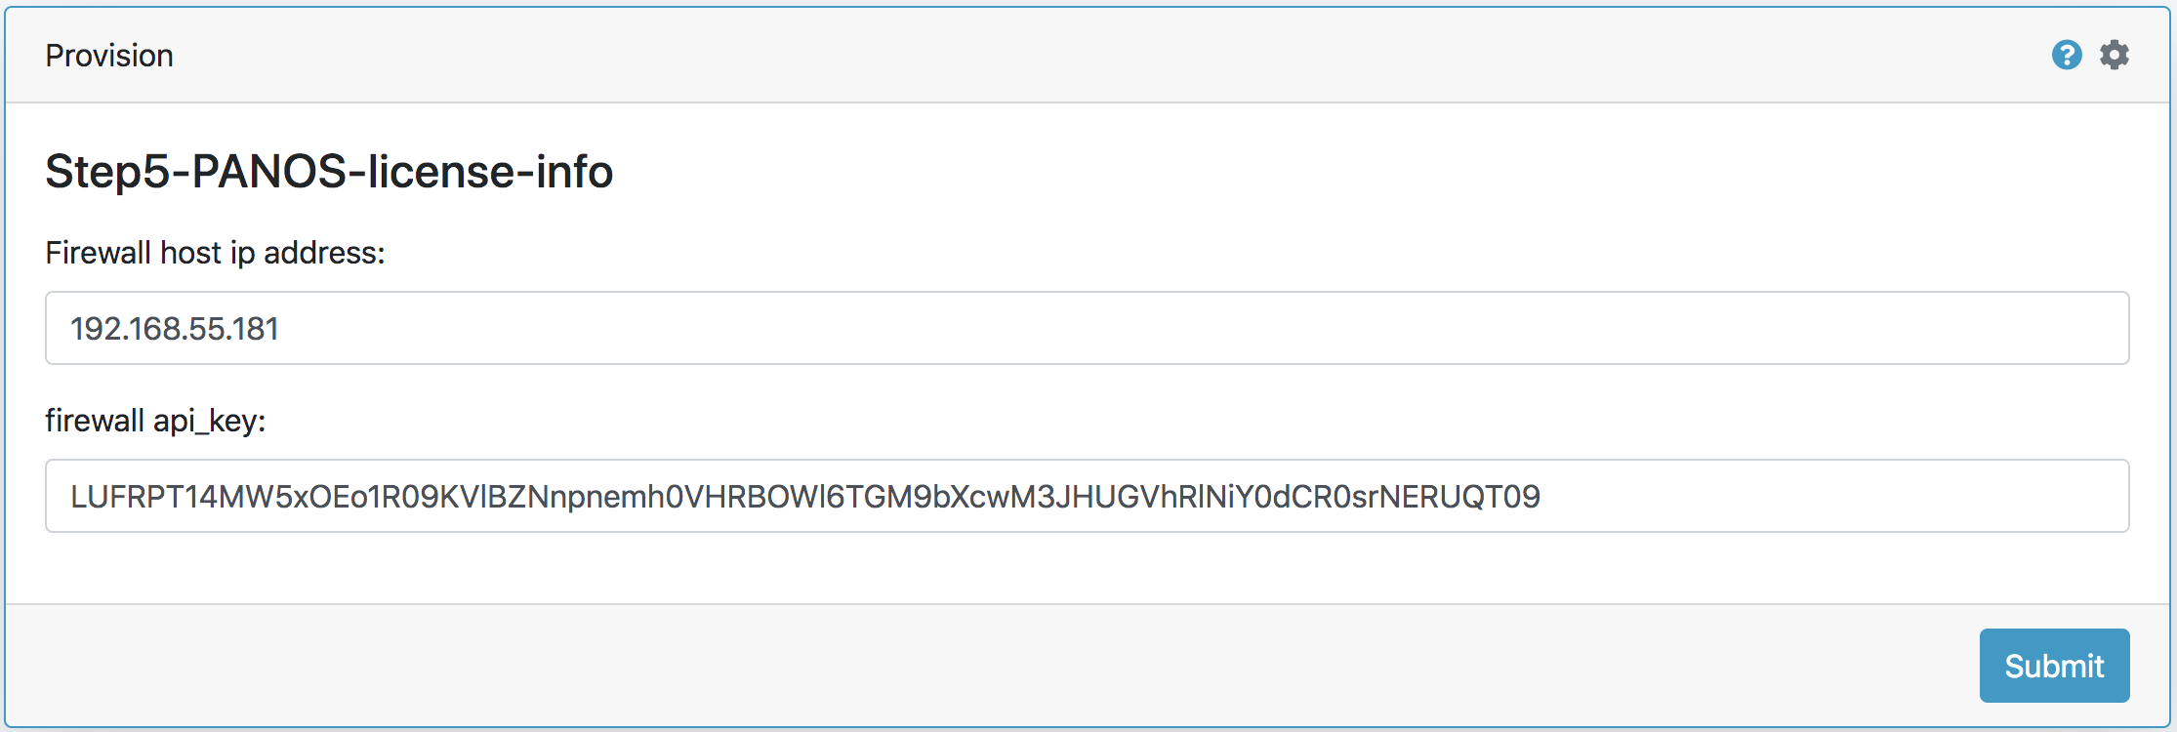

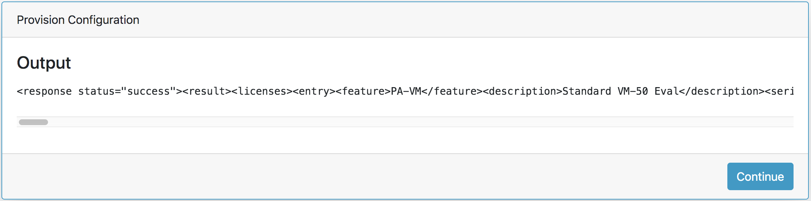

* Click Step 6 – Using the Licensing API and Auth-code to check the Auth-code usage.

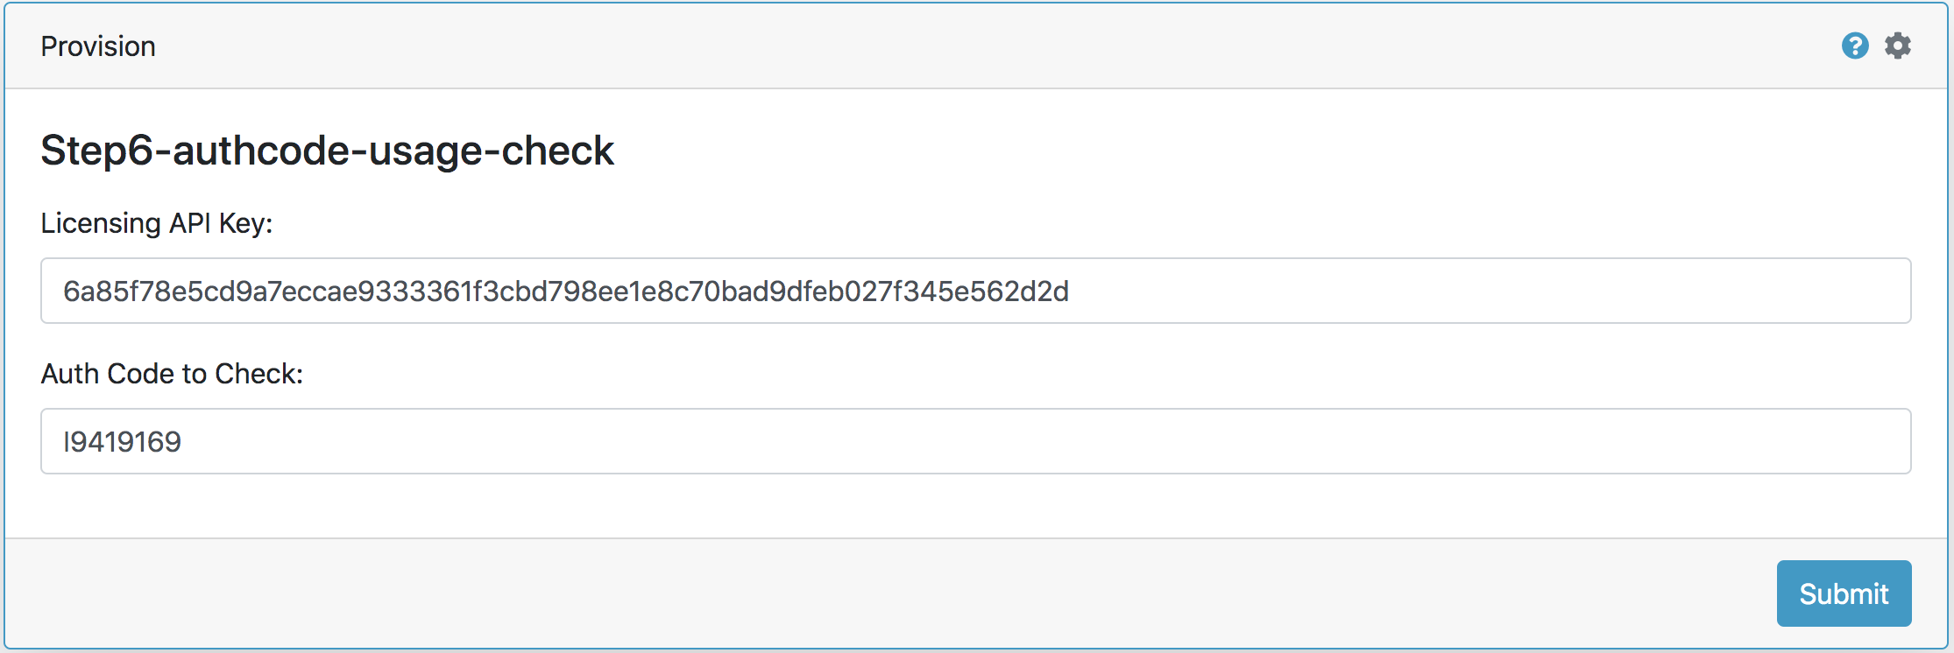

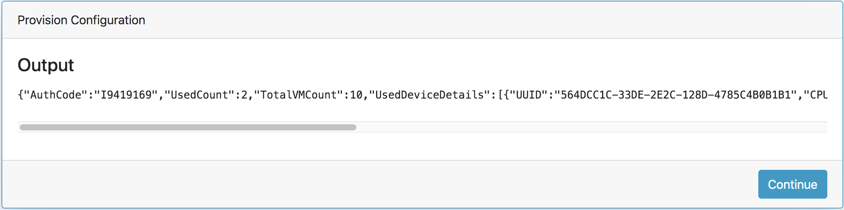

# Github Repository

* https://github.com/zhiyhappy/ezhi-activate-license-offline.git

# Requirements

* Panhandler
* PAN-OS 8.1 or greater